This note deals with

European Union as an institution

India’s relations with EU

European Union

Evolution of EU and major institutions
- Refer class notes

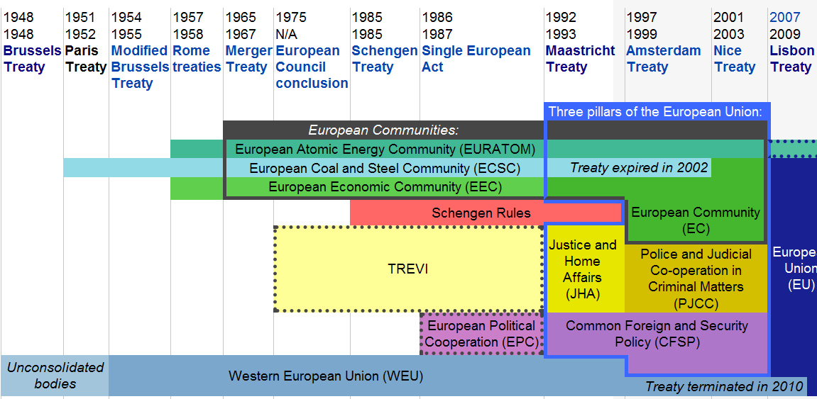
Schengen Area
- 25 countries
- Schengen rules absorbed into European Union law by the Amsterdam Treaty in 1999
- Includes three non-EU member states: Iceland, Norway, Switzerland
- Iceland and UK have opted out of implementing the agreement
- Covers a population of about 400 mn people
- Involves eliminating border controls with other Schengen members while simultaneously strengthening border controls with non-member states
- Provisions on
  - Temporary entry of persons
  - Harmonisation of external border controls
  - Cross-border police
  - Judicial co-operation

Euro
- European Currency Unit
  - Precursor of Euro
  - A basket of the currencies of European Community member states, that was used as the unit of account of the European Community
  - Used since 1979
  - Replaced by Euro
- Euro
  - Maastricht treaty
  - Launched in 1999
  - Notes and coins launched in 2001

Eurozone
- Economic and monetary union of 17 EU member states that have adopted the Euro
- Monetary policy is the responsibility of the European Central Bank
- No common fiscal policy <basic weakeness>
- Withstood the financial crisis of 2008-09

Eurozone Crisis
- Major countries facing crisis
  - PIGS (Portugal, Ireland, Greece, Spain)
- 2008 crisis hastened the fall
- Greece on the verge of default
- Portuguese and Irish Eurobonds demoted to junk status
- Italian and Belgian bonds under speculative attack
- The default of one country may trigger a domino effect and bring down some of Europe’s major banks
- Cause
  - Accumulated large public debts due to expansionary fiscal policies
  - Eurozone removed the policy instruments of exchange rate management and monetary policy and partially fiscal policy out of the domain of national policymaking

What is needed?
- Deeper structural reform
- Europe must direct more investments towards the crisis ridden countries to increase their GDP
- Monetary integration alone cannot help. Some steps to be taken towards fiscal integration
- Greater powers should be given to the European Central Bank
Probable impact of a European sovereign default on India
- Exports to Europe will be hit
- Effect on stock markets
- European investments in India may dry up
- Some of the world’s largest banks hold these debts. A default may lead to weakening of the financial status of these banks. Another financial meltdown?

Oct 28, 2011
- The leaders of the Eurozone reached a new deal for dealing with the crisis
- The new deal has three elements
- Firstly, the leaders persuaded reluctant private banks holding Greek debt to accept a write-off of 50 per cent of their returns
  - The move is expected to cut Greece’s debt burden to 120 per cent of its GDP in 2020. Without it, the debt would have risen to 180 percent
- Secondly, the corpus of the main euro bailout fund, the European Financial Stability Facility (EFSF), is being increased substantially from 440 bn Euro to 1 trillion Euro
  - This is meant to prevent market panic from spreading to other countries, notably Italy
- Thirdly, European banks are asked to raise about Euro 106 bn in new capital by June 2012.
  - Such massive recapitalisation, will shield not only the banks against losses resulting from government defaults but will also protect the larger economies such as Spain and Italy from slipping into default.
- The success of the package is contingent on whether, and to what extent, Greece and the Eurozone are able to convince the markets that the worst will be over soon

India-EU Relations
- The 11th India-EU summit was held in December 2010 at Brussels
- This was the first India-EU summit after Lisbon Treaty came into force
- Manmohan Singh called for ‘taking the lead in avoiding protectionist trends, keeping markets open and encouraging the free flow of and movement of people’ by the two sides

Trade
- The two sides have been negotiating a FTA
- The major stumbling blocks are:
  - EU’s insistence on the environment and labor standards
  - Intellectual property rights of generic drugs
  - Resistance of EU member states over free movement of Indian nationals
- India has a high tariff regime
  - So India will have much to lose from FTA (?)
- FDI multibrand
- Legal sector investment

Smaller Countries

Belgium
- India’s third largest trade partner in EU
- Trade dominated by Diamonds with 75 pc of the bilateral trade in jewellery

