Art of Open Learning |  | - CURRENT AFFAIRS  - OCTOBER 2nd Week
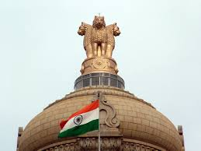  Art of Open Learning is an organization which believes in free and open education. Our motto: “Sa Vidya ya Vimuktaye”: Knowledge is which liberates the mind.  Siddharth Rathore, Assistant Professor, Delhi University |  | Paper 2  International Relations  Paper 2  Polity, Governance, National Issues  Paper 3  Indian Economy & topical issues  Paper 3  Science & Tech., Environment

